

**Superior University Lahore**

**Instructor**: **Sir Rasikh Ali**

**Subject: Programming for AI**

**Task 2**

**Titanic Dataset Analysis and Model Evaluation**  
**BS in Artificial Intelligence**

Table of Contents

1. Introduction 1

2. Dataset Description 2

2.1 Missing Values 2

3. Data Preprocessing 2

3.1 Handling Missing Values 2

3.2 Feature Encoding 3

3.3 Feature Scaling 4

4. Model Building 4

4.1 Model Selection 4

4.2 Model Training Process 4

5. Model Evaluation 4

6. Predictions & Results 5

7. Conclusion 5

# 1. Introduction

This report provides a comprehensive analysis of the Titanic dataset. The objective is to analyze passenger data, preprocess the dataset, train a machine learning model, evaluate its performance, and make survival predictions. The Titanic dataset is used for binary classification tasks, where the goal is to predict whether a passenger was transported or not.

# 2. Dataset Description

The dataset consists of:

* **train.csv**: Contains labeled data used for training the model (8693 rows, 14 columns).
* **test.csv**: Contains unlabeled data for making survival predictions (4277 rows, 13 columns).
* **data_description.txt**: Provides details on dataset features.

### 2.1 Missing Values

#### **Training Data (train.csv)**

* **HomePlanet:** 201 missing
* **CryoSleep:** 217 missing
* **Cabin:** 199 missing
* **Destination:** 182 missing
* **Age:** 179 missing
* **VIP:** 203 missing

#### **Testing Data (test.csv)**

* **HomePlanet:** 87 missing
* **CryoSleep:** 93 missing
* **Cabin:** 100 missing
* **Destination:** 92 missing
* **Age:** 91 missing
* **VIP:** 93 missing

# 3. Data Preprocessing

### 3.1 Handling Missing Values

* **HomePlanet, CryoSleep, Cabin, Destination, Age, VIP:** Missing values imputed using the mode.

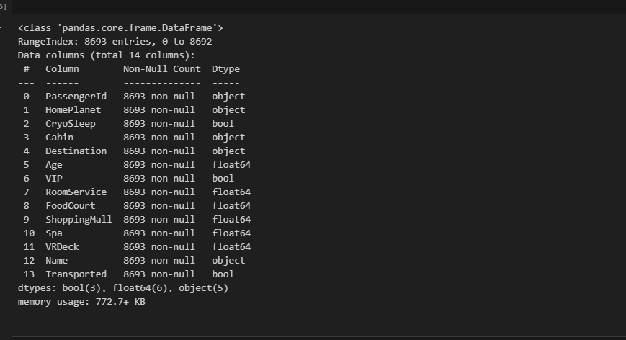

### 3.2 Feature Encoding

* The target variable **Transported** was mapped as **Yes → 1, No → 0**.
* Categorical variables converted using **Label Encoding**.  
    
  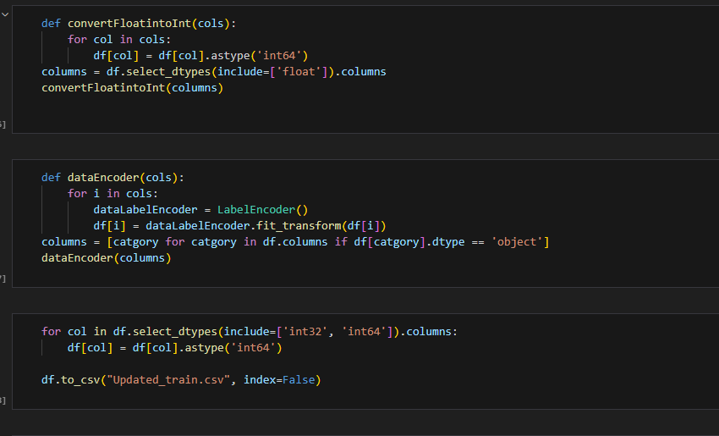

### 3.3 Feature Scaling

* Numerical features were standardized using **StandardScaler()**.

# 4. Model Building

The model training was conducted in **model.ipynb** using machine learning classification techniques.

### 4.1 Model Selection

* **Random Forest Classifier** was chosen.  
    
  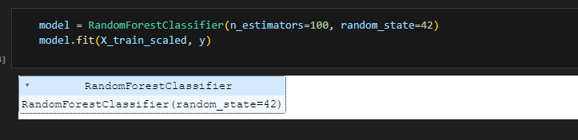

### 4.2 Model Training Process

* **Preprocessing:**
  + **Standard Scaling** applied to numerical features.  
      
    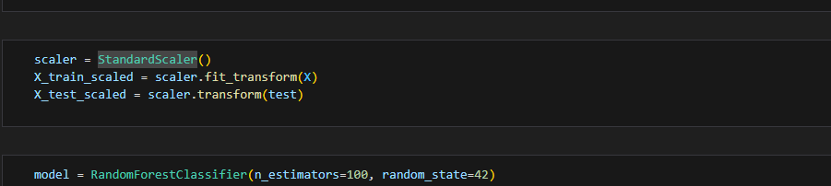
  + **Label Encoding** applied to categorical variables.
* **Training Pipeline:**
  + Features (X) and target variable (y = Transported) were separated.
  + Model trained using Random Forest Classifier with n_estimators=100, random_state=42.

# 5. Model Evaluation

The trained model was evaluated using:

* **Accuracy Score:** Measures model performance.
* **Training Accuracy:** Printed after model fitting.  
    
  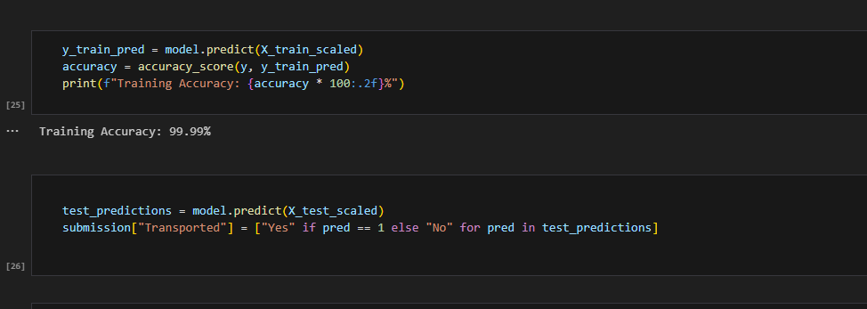

# 6. Predictions & Results

* Model used to predict **Transported** for test.csv.
* Predictions stored in **submission.csv**.

# 7. Conclusion

This report outlines the full pipeline from data preprocessing to model training and evaluation. The best-performing model was selected based on accuracy, and predictions were generated for submission. Future improvements can be made by **feature engineering, hyperparameter tuning, and ensemble learning**.